**Determine a meaningful brand name for your project.**

TBS (Terps Business Solutions)

**Mission Statement**

As a business solution consultancy, we aim to provide actionable insights to the Maryland Baseball team by identifying key strengths and weaknesses based on historical data.

**Mission Objectives**

* **Historical performance:** What are the win rates for each year?
* **High-value opponents:** Among the opponents’ teams which the Terps have played at least 10 times, who has UMD faced the most?
* **Performance differential by stadium:** At which non-home stadium do we have the top 20 win rates? How many games have been played at the respective stadiums?
* **Performance differential by type of games:** How does the win rate differ for away, home, and neutral matches in each conference?

**Describe business processes/transactions in sentences.**

* Access the database for the baseball schedule for UMD at: https://umterps.com/sports/baseball/schedule/2000
* Download the text versions of the schedules for the years 1999-2023.
* Collate all the years into a singular table by adding a “year” attribute for each dataset.
* Export these into a spreadsheet with delimited columns by the column names provided

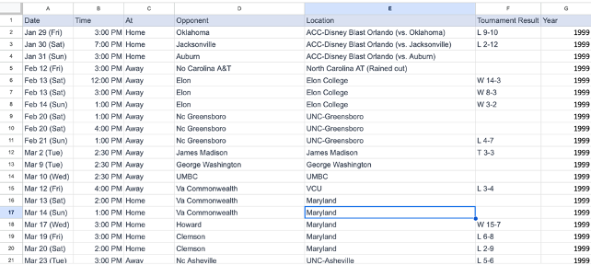

With regards to the data:

1. There are three types of games that have been held: home, away, and neutral, within the measured time-frames.

2. The home stadium does not necessarily stay the same during a given year.

3. There exist some null values in the data for game type, time, and result.

4. Some data was not clean, including those for the stadium names. We have cleaned them to ensure that there are no redundant or missing values. These values were found using a pivot table.

**ER Schema**

Entities, Attributes, and Primary Keys

Team (**teamId**, teamName)

Opponent (**opntId**, opntName)

Conference (**confId**, confName)

Year (**year**)

Location (**locnId**, locnName)

Relationships, Attributes, Degrees, Participating Entities and Constraints

Play (gameSchedule, gameDate, gameTime, gameType, gameTeamScore, gameOpponentScore):

Ternary Relationship

1 team and 1 opponent to 1 or more years

1 opponent in 1 year to 1 and only 1 teams

1 team and 1 year to 1 or more opponent

Perform: Ternary Relationship

1 conference and 1 location to 1 or more opponents

1 location and 1 opponents to 0 or more conference

1 opponents and 1 conference to 1 or more location

**ER Diagram**

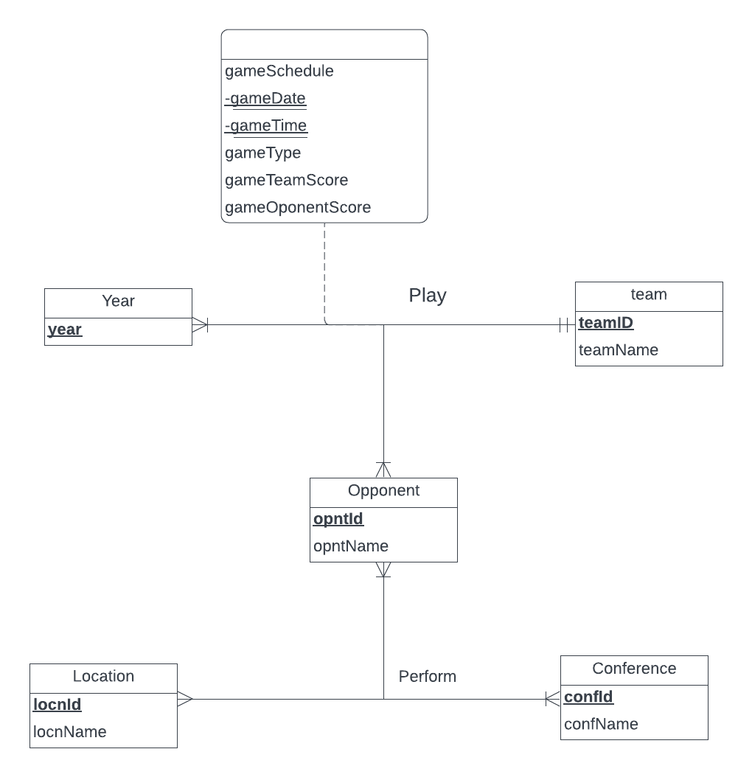

**Relational schema**

Team (**teamId**, teamName)

Opponent (**opntId**, opntName)

Conference (**confId**, confName)

Year (**year**)

Location (**locnId**, locnName)

Perform (***opntId****,* ***locnId****,* ***confId***)

Play(***teamId,******opntId,*** ***year*, gameDate, gameTime**, gameType, gameTeamScore, gameOpponentScore)

Business Rules:

[R1] If an opponent is deleted from the database, their performance schedule information should be preserved.

[R2] If an opponent is updated, a corresponding update should occur within their performance schedule information.

[R3] If a location is deleted, its prior involvement as part of previous game schedules should be preserved.

[R4] If a location is updated, a corresponding update should occur within its entries for performance schedules.

[R5] If a conference is deleted, performances at the conference should be preserved.

[R6] If a conference is updated, a corresponding update should occur within its entries for performance schedules.

[R7] If a team is deleted, its games should be preserved in the database.

[R8] If a team is updated, games that involve the team should also be updated accordingly.

[R9] If an opponent is deleted, the games of the opponent should be preserved.

[R10] If an opponent is updated, games that include the opponent should also be updated accordingly.

[R11] If a year is deleted, games for that year should be preserved.

[R12] If a year is updated, corresponding games should also have their years updated to reflect the change.

**Referential integrity:**

|  |  |  |  |  |  |  |  |
| --- | --- | --- | --- | --- | --- | --- | --- |
| Relation | Foreign Key | Base Relation | Primary Key | Business Rule | Constraint: ON DELETE | Business Rule | Constraint: ON UPDATE |
| Play | teamId | Team | teamId | R7 | NO ACTION | R8 | CASCADE |
| Play | opntId | Opponent | opntId | R9 | NO ACTION | R10 | CASCADE |
| Play | year | Year | year | R11 | NO ACTION | R12 | CASCADE |
| Perform | opntId | Opponent | opntId | R1 | NO ACTION | R2 | CASCADE |
| Perform | locnId | Location | locnId | R3 | NO ACTION | R4 | CASCADE |
| Perform | confId | Conference | confId | R5 | NO ACTION | R6 | CASCADE |